Final Report

Name: Charles Taggart
Course / Cohort: FSDI 115 / CH 65
Assignment: 115 Final Report
GitHub Repository Link: https://github.com/chucktagg83/fsdi-115-project.git

Evidence of Functionality
Frontend/UI:
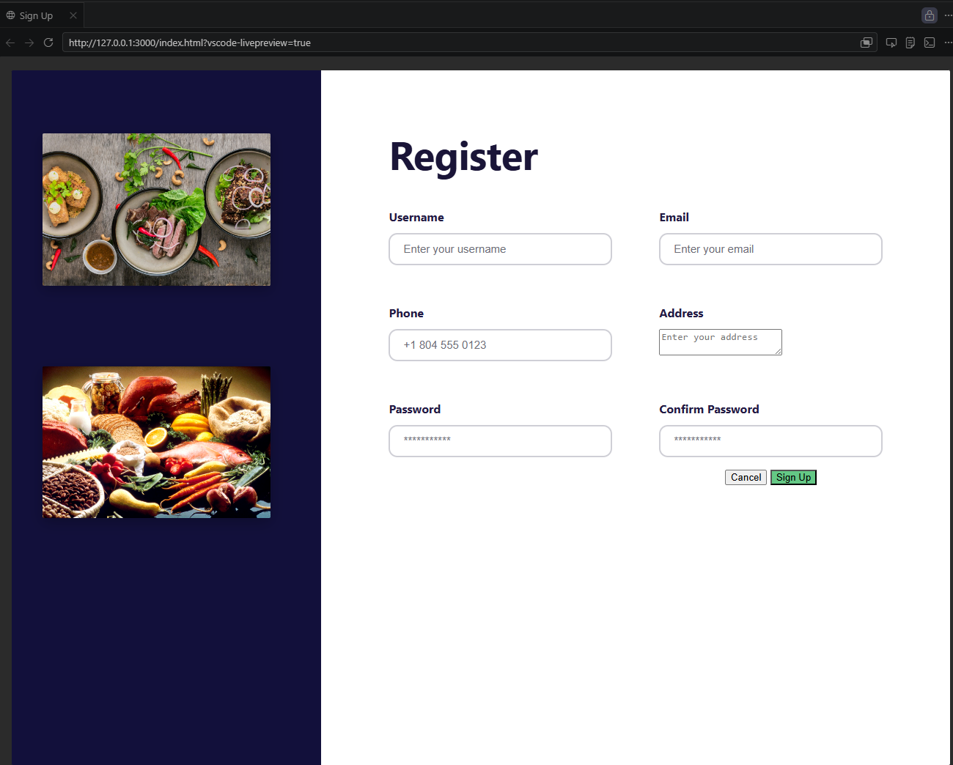

Retrospective
1.Which part of the project was the most difficult or challenging for you, and why?
I struggled a bit with the CSS portion, I understood what we did throughout the process, but struggled a bit with getting the layout to look how I wanted.

2. What did you enjoy the most or learn the most from while working on this project, and why? I enjoyed having the extra classes that covered some of the basic information. It was nice to go back and have a chance to go through html and CSS again and reenforce some of those concepts.

AI Disclosure (Required) – Highlight the one that applies
- I did not use AI
- I used AI for help
- AI generated parts of my code (if it’s the case, provide an explanation of the code in your own words).

